CAMPUS CAFÉ ORDERING SYSTEM
Object-Oriented Programming Laboratory Exercise
Written Report

Name: Elijah Shem E. Yape
Course / Section: BSIT — ITS 202 (Object-Oriented Programming)
Date: November 9, 2026
Exercise Title: Campus Café Ordering System

1. OOP Concepts Explained
1. if Statement: Used to check a single condition. In Pastry.java, we check if the item is warmed (isWarmed == true) to add 10 pesos to the price. In Meal.java, we check if it is upsized to add 20 pesos.
2. if-else Statement: Used to pick between different choices. In Beverage.java, we check the size string: if size is 'L' add 25 pesos, else if size is 'M' add 15 pesos, else use base price. Also used in Order.java to give students a 10% discount.
3. Classes and Objects: A class is like a blueprint or template, and an object is a real item built using that template. We created 7 class blueprints (MenuItem, Beverage, Pastry, Meal, Customer, Order, CafeApp) and created real objects in CafeApp using the 'new' keyword.
4. Attributes and Behaviors: Attributes are variables that hold an object's information (like name, basePrice, size). Behaviors are methods (functions) that perform actions (like computePrice() or printReceipt()).
5. Object Interaction: This happens when two objects work together. Our Order object holds a Customer object and MenuItem objects inside it, and updates the Customer's loyalty points when the bill is printed.
6. Java Naming Conventions: Rules for naming code elements so they are easy to read: PascalCase for classes (e.g., MenuItem), camelCase for variables/methods (e.g., computePrice), and ALL_CAPS for constants.
7. Default Constructor: A special method with no parameters that sets safe starting values when an object is created without info (e.g., setting name to 'Unnamed Item' and price to 0.0).
8. Parameterized Constructor: A constructor that lets us pass initial values directly when creating an object (e.g., new Beverage('Iced Latte', 120.0, 'B-01', 'L')).
9. Constructor Overloading: Creating multiple constructors in the same class with different parameters. Customer has 3 constructors so we can create a customer with 0, 1, or 2 details.
10. public, private, and protected: Keywords that control who can touch our data. 'private' hides variables inside their own class, 'protected' allows child classes to access them, and 'public' makes methods accessible everywhere.
11. Getters, Setters, and Data Hiding: Getters read data, and Setters update data. Setters protect data by checking inputs (e.g., setBasePrice rejects negative numbers using an if check).
12. Method Overloading: Having two methods in the same class with the exact same name but different input parameters (e.g., addPoints(int) and addPoints(double)).
13. Method Overriding: When a child class re-writes a method from its parent class to give it specific behavior. Subclasses override computePrice() and getDescription() using @Override.
14. Abstraction: Creating a general parent class (MenuItem) using the 'abstract' keyword that outlines required methods (like abstract computePrice()) without writing the exact implementation body.

2. Program Actual Output

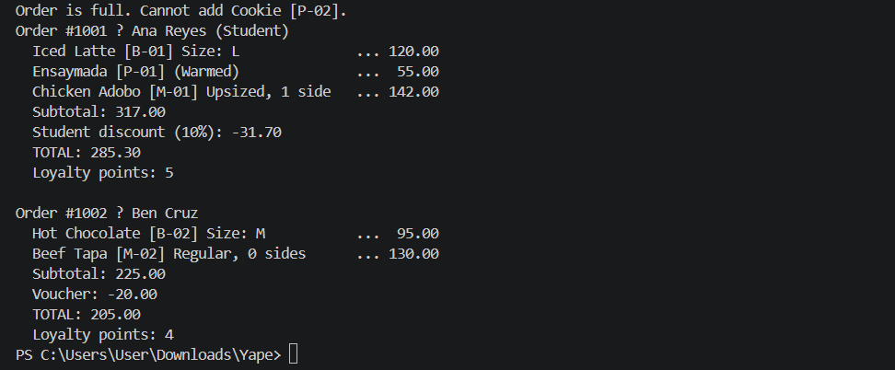

3. Challenges Encountered
- Storing Items Without ArrayLists
Problem: We were forbidden from using ArrayList or collections, which are normally used to store an unpredictable list of items.
Solution: We created 3 separate fields (item1, item2, item3) inside Order and used an itemCount counter variable to fill slot by slot while blocking a 4th item.

- Calling computePrice() on Different Subclasses
Problem: Each food type computes its price differently, but our Order needed to sum them up cleanly.
Solution: We called item.computePrice() on the abstract MenuItem reference. Thanks to polymorphism, Java automatically picked the right formula based on whether the item was a Beverage, Pastry, or Meal.

- Data Protection & Preventing Invalid Inputs
Problem: Making sure user code cannot set negative prices or invalid drink sizes.
Solution: We added if-statement validation inside setter methods (like setBasePrice and setSize) to reject bad values and display an error message before saving.

- Unfamiliar Code & Abstract Classes
Problem: Understanding new OOP syntax like abstract class and abstract methods was confusing at first, especially since an abstract class cannot be instantiated directly with new.
Solution: We reviewed the exercise guidelines and learned that MenuItem acts like a master template. We implemented all required subclass methods in Beverage, Pastry, and Meal to ensure the program compiled and ran smoothly.

- Solving Coding Difficulties & Logic Errors
  - Problem: Troubleshooting logic bugs during development, such as ensuring voucher discounts do not reduce the total price below 0.0, or formatting receipt output correctly.
  - Solution: We trace-tested methods step-by-step and added safety checks like Math.max(0.0, total - voucher) inside Order.computeTotal() to resolve calculation errors.

